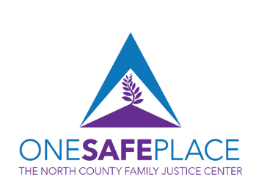

The North County Family Justice Center, “One Safe Place” will be a place where child, adult, and elderly victims of abuse and their families will walk through the doors and receive acute crisis-care, advocacy, counseling, legal services, connection to shelter and housing, long term mentoring, workforce readiness, and educational opportunities – all under one roof. The goals of the North County Family Justice Center will be to provide hope, healing, and justice by creating pathways forward for victims and their families as they move through the process of “surviving to thriving.”

Currently, victims and survivors must travel to several different locations across North County to receive a full continuum of support which can be exhausting and a barrier to getting healed. While existing service providers provide excellent services, there is little interconnectivity, and providers often operate in silos, rather than under one umbrella of victim care.

When someone comes to One Safe Place, their risks and needs will first be assessed so a victim-centered, culturally competent, and survivor-led customized health and safety plan can be developed. A trained team of navigators and care coordinators will then stand alongside the survivor to ensure the survivor understands the various available service options, can physically attend appointments, and can successfully engage and participate in a customized plan of care focusing on the survivor’s physical, mental, and emotional well-being.

One Safe Place, a recently designated “Trauma Recovery Center,” will revolutionize victim services in San Diego County, because, for the first time, a nationally accredited Child Advocacy Center will be housed under the same roof as a nationally-known health care provider, along with law enforcement and other general victim services. This is important because we know that children who suffer abuse are more likely to have unhealthy outcomes later in life. We also recognize the significant association between exposure to trauma and involvement with the criminal justice system, especially for individuals of color. The vision of One Safe Place is grounded in research such as the landmark 1995-1997 ACES (Adverse Childhood Experiences) study and seeks to prevent a next generation of abuse by intervening early in one’s trauma lifespan, disrupting a potential school to prison pipeline, and providing equal access to all communities.

One Safe Place will be “the community’s building,” home to a state-of-the-art training and conference center where community groups and organizations can host seminars, educational trainings, and meetings that center around helping families thrive.

One Safe Place will be much more than a building – it will be a haven that interrupts cycles of abuse, prevents future generations of abuse, breeds resiliency, and provides hope to family members who suffer from the ripple effects of abuse. Victims and survivors from all ages and all crime types can find help here. Our goal is to leave a lasting footprint and legacy, showing directly that our community takes care of its most vulnerable.

